

Competitor Analysis Team – 3

Powered Resume Builder

**Submitted To: Prof. Joumana Dargham**

**Submitted By: Darshansinh Dilipsinh Devda (40261713) Pranaykumar R. Chauhan (40266722)**

**Burhanuddin Savliwala (40273764)**

**Amal Gupta (40293339)**

**Chadi Abboud (40189413)**

## Competitor Analysis:

When assessing the landscape for a resume-building platform, it's important to identify key competitors, analyze their features, and understand how Powered Resume Builder can differentiate itself. Here’s a detailed competitor analysis:

## Resume.io:

Resume.io is a widely recognized online resume-building platform that provides users with a variety of templates and tools designed to streamline the resume creation process. The platform focuses on helping job seekers produce professional, ATS-compliant resumes quickly and efficiently by offering step-by-step guidance and customization options.

## SWOT Analysis:

* + **Strengths:**
* Ease of Use: User-friendly interface with drag-and-drop features and pre-designed templates for quick resume building.
* ATS Optimization: Built-in features that ensure resumes are ATS-compliant, increasing the chances of passing initial screening.
* Analytics: Provides resume performance analytics, such as views and downloads.
* Affordable Pricing: Offers affordable subscription options, including free trials for basic use.

## Weaknesses:

* Limited Customization: Some users report a lack of deep customization beyond the provided templates.
* Dependence on Templates: Over-reliance on templates may limit creativity and uniqueness for job seekers in creative industries.
* Freemium Limitations: Free versions come with watermarks and limited functionality, which might frustrate users looking for more advanced features

## Opportunities:

* Expansion of Features: Resume.io could expand its analytics tools, providing deeper insights into how resumes perform in different industries.
* Localization: Opportunity to support more languages and adapt templates for non-Western markets.
* AI Integration: Enhanced AI features, such as real-time suggestions for improvement or job-specific optimizations.

## Threats:

* Increased Competition: Other resume builders offer similar features with more flexibility, which can attract users looking for more advanced options.
* ATS Evolution: As ATS systems evolve, resume builders need to adapt quickly or risk becoming obsolete in the face of new technologies.

## Resume Worded:

Resume Worded is an innovative online resume and cover letter-building platform that leverages AI to provide personalized feedback and suggestions. The tool is designed to help users optimize their job application materials for ATS compatibility and enhance their chances of landing interviews by tailoring content to specific job descriptions.

## SWOT Analysis:

* + **Strengths:**
    - Real-Time Feedback: Provides instant, detailed feedback on resumes and LinkedIn profiles, helping users optimize their documents for ATS.
    - AI-Driven Insights: Uses AI to score resumes and suggest improvements for ATS optimization, keyword usage, and formatting.
    - LinkedIn Review: Unique feature that allows users to optimize their LinkedIn profiles based on the same ATS principles.

## Weaknesses:

* + - Limited Templates: Compared to competitors, Resume Worded lacks variety in resume templates, focusing more on feedback than aesthetics.
    - Premium Pricing: Some advanced features, such as personalized feedback and full reports, require paid access, limiting the free version's usefulness.

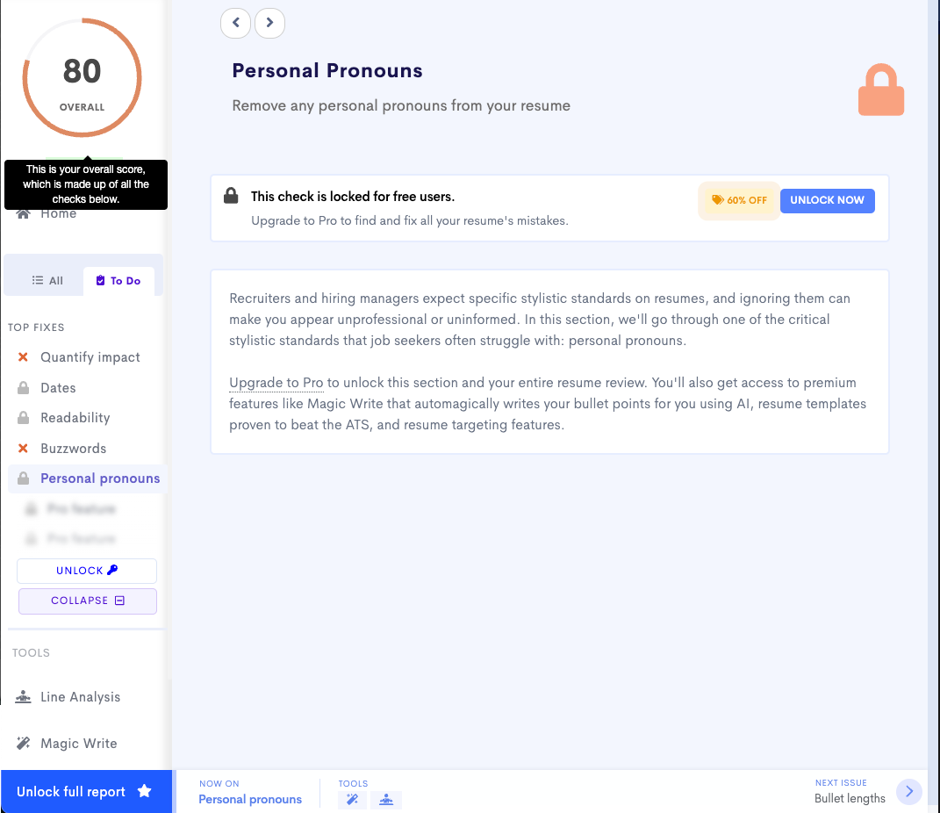

## Opportunities:

* + - Career Coaching: Expanding into career coaching or interview preparation could attract users seeking comprehensive career support.
    - Industry-Specific Optimization: Offering tailored advice for different industries or roles would improve user experience and targeted results.

## Threats:

* + - Overcrowded Market: As the market becomes saturated with AI-driven resume tools, Resume Worded may face competition from platforms offering more design

flexibility.

* + - User Reliance on LinkedIn: If LinkedIn introduces its own native optimization tools, this could diminish the appeal of Resume Worded’s LinkedIn profile review feature.

## Enhancv:

Enhancv is a modern online resume builder that focuses on creating visually appealing and personalized resumes. The platform offers a range of customizable templates and design options, allowing users to showcase their skills, experience, and personality effectively. Enhancv emphasizes the importance of storytelling in resumes, encouraging users to present their professional narratives in a compelling manner.

## SWOT Analysis:

* + **Strengths:**
    - Creative and Visual Resumes: Offers visually appealing resume templates that stand out while remaining ATS-compliant, making it ideal for creative professionals.
    - Customization: Users can deeply customize their resumes with various sections, colors, fonts, and layouts, providing more design freedom.
    - Customer Support: Known for providing solid customer support with helpful advice and suggestions.

## Weaknesses:

* + - Price Point: Enhancv’s premium options are relatively expensive compared to other competitors, which may deter budget-conscious users.
    - ATS Challenges for Visual Resumes: While the platform emphasizes creativity, some visually heavy resumes may not be as ATS-compatible as simpler formats

## Opportunities:

* + - Niche Market Appeal: Enhancv can continue to appeal to niche markets like creative professionals, freelancers, and designers by offering even more specialized templates.
    - Global Expansion: More multilingual support and country-specific templates could help Enhancv capture a wider global audience.

## Threats:

* + - Balancing Creativity and ATS: As ATS systems evolve, Enhancv may face difficulties balancing creative freedom with ATS requirements, which could turn off users looking for functionality over design.
    - Competition from Free Tools: Other free or lower-cost tools with ATS-compliance features may threaten Enhancv’s premium user base.